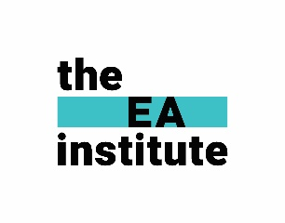
The EA Institute: Request for Professional Development Support Letter
Copy and paste below, edit the yellow sections and adjust the tone as necessary.
Good Luck!

Subject: Request for Professional Development - EA Institute [Course/Membership]
Dear [Executive or HR Manager's Name],
I'm writing to request your support for a professional development opportunity that I believe will substantially enhance my effectiveness in supporting you and contributing to our organisation's success.
The Opportunity
The EA Institute offers a [insert course/membership level] specifically tailored for Executive Assistants who aim to operate at a strategic level. This program focuses on advanced leadership skills, business acumen, and executive-level support capabilities that would directly benefit my work with you and our team.
Investment Value
The program requires an investment of [insert cost] and [insert time commitment]. I believe the return on this investment will be significant both in terms of my professional growth and the enhanced support I'll provide to you and our organisation.
Key Benefits
The comprehensive Curriculum includes:
- Strategic business partnership - Developing foresight to anticipate needs and provide truly proactive support aligned with our business goals
- Advanced efficiency systems - Learning cutting-edge tools and frameworks to optimise workflows, time management, and decision-making processes
- Executive-level communication - Refining skills to better represent you and manage complex stakeholder relationships
- Project management excellence - Enhancing capabilities to lead initiatives independently, freeing your time for higher-level priorities
Implementation Plan
If approved, I would:
- Begin the program on [proposed start date]
- Apply new skills immediately to our current workflows
- Share relevant insights with our team where appropriate
- Provide a brief summary of key learnings and implementation results
Request
I'm requesting your approval to enrol in this program by [decision deadline]. I'd be happy to discuss this opportunity further and answer any questions you might have about how this investment will directly benefit your priorities and our team's objectives.
Thank you for considering this professional development request. I'm excited about the potential to elevate my support and contribute even more meaningfully to our success.
Regards,
[Your Name]

